Project Name: Online User Management System

Application/Software: Web Application

Module Name: Login, Registration and Payment

Version: V1.0

Programming Language: Java

IDE/Tool Used: VS Code / Online Java Compiler

Database Used: MySQL

Operating System: Windows 11

Browser: Google Chrome

Test Environment: QA Environment

Tester Name:Desai Mohit

Test Date: 30-07-2026

Test Scenarios

Scenario ID: 5a

Test Steps:

- Open the login page.
- Enter username.
- Leave password blank.
- Click Login.

Test Input:

Username: admin
Password: Blank

Expected Result:

System should display a validation message for the empty
password.

Actual Result:

No password validation message is displayed.
Status:

FAIL

Comments:

BUG-001 identified – Empty password validation is missing. Severity: Medium, Priority: High.

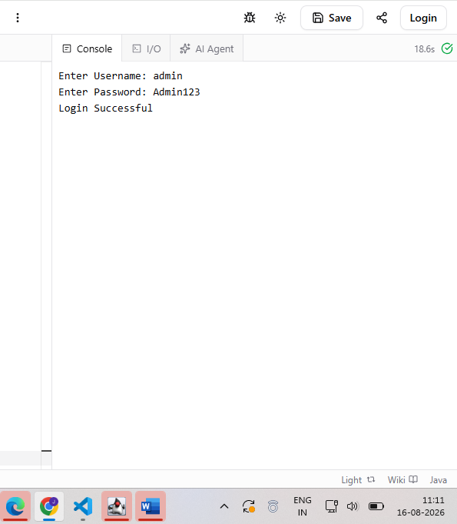

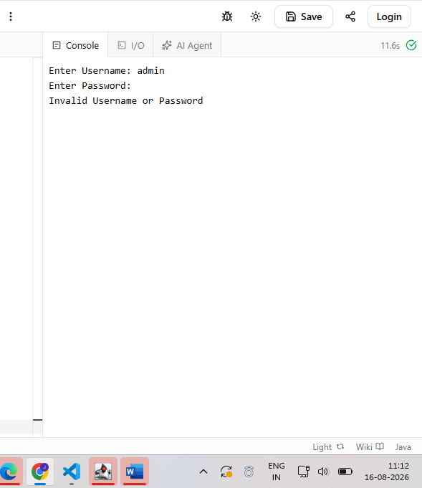

Scenario ID: 5b

Test Steps:

- Open the login page.
- Enter valid username.
- Enter valid password.
- Click Login.

Test Input:

Username: admin
Password: Admin123

Expected Result:

User should be logged in successfully.

Actual Result:

Login is successful.

Status:

PASS

Comments:

Normal login functionality works successfully.

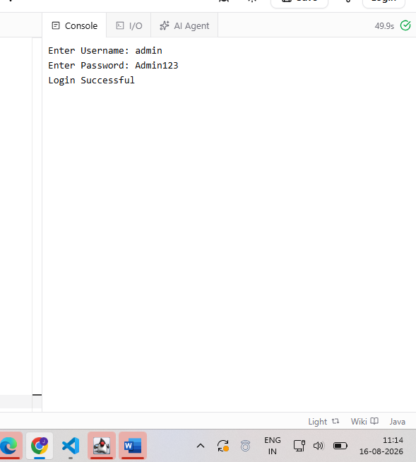

Scenario ID: 5c

Test Steps:

1.Open the login page.
2.Enter username.
3.Leave password blank.
4.Click Login again.

Test Input:

Username: admin
Password: Blank

Expected Result:

System should prevent login and display password validation.

Actual Result:

No password validation message is displayed.

Status:

FAIL

Comments:

BUG-001 reproduced successfully. Severity: Medium, Priority: High.

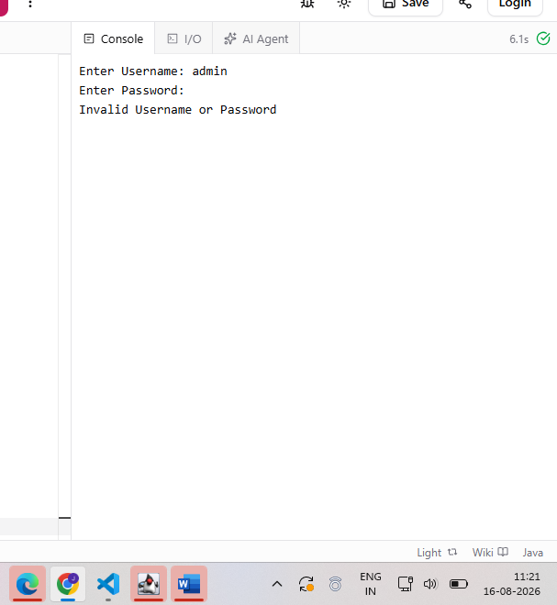

Scenario ID: 5d

Test Steps:

1.Open the login page.
2.Leave username blank.
3.Enter password.
4.Click Login.
Test Input:

Username: Blank
Password: Admin123

Expected Result:

System should display username validation or reject the login.

Actual Result:

Login is rejected.

Status:

PASS

Comments:

Username validation was checked successfully.

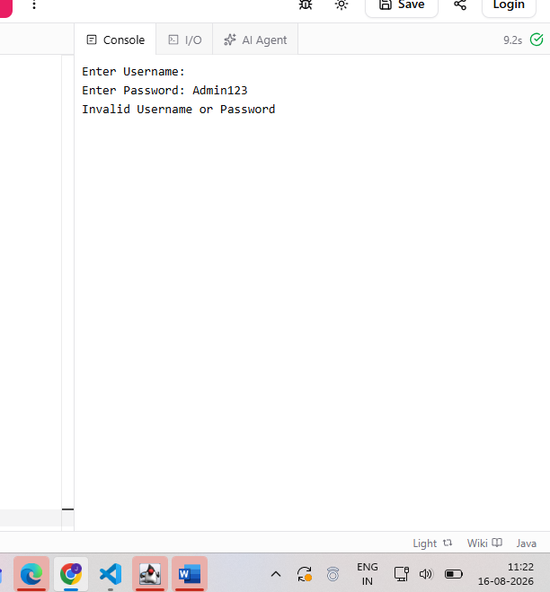

Scenario ID: 5e

Test Steps:

1.Open the login page.
2.Enter invalid username.
3.Enter invalid password.
4.Click Login.
Test Input:

Username: wronguser
Password: wrong123

Expected Result:

System should reject invalid credentials and display an error message.

Actual Result:

Invalid username or password message is displayed.

Status:

PASS

Comments:

Invalid credential handling works successfully.

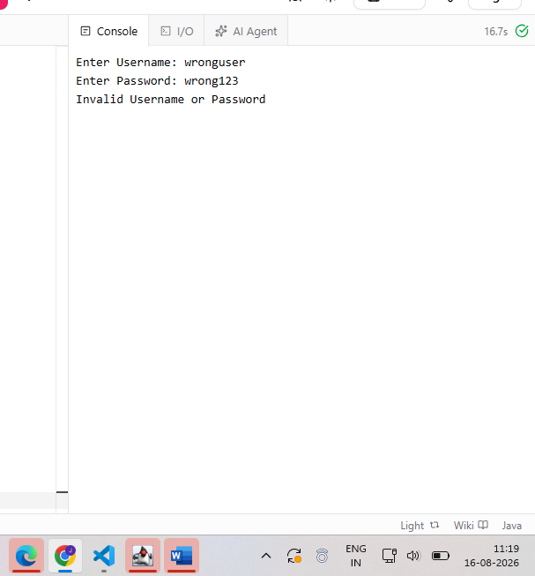

Scenario ID: 5f

Test Steps:

1.Open the registration page.
2.Enter username and email.
3.Enter a weak password.
4.Submit registration.

Test Input:

Username: user1

Email: user@test.com
Password: 12345

Expected Result:

System should reject the weak password and display password-strength validation.

Actual Result:

Weak password is accepted without proper password-strength validation.

Status:

FAIL

Comments:

BUG-002 identified – Weak password is accepted. Severity: Low, Priority: Medium.
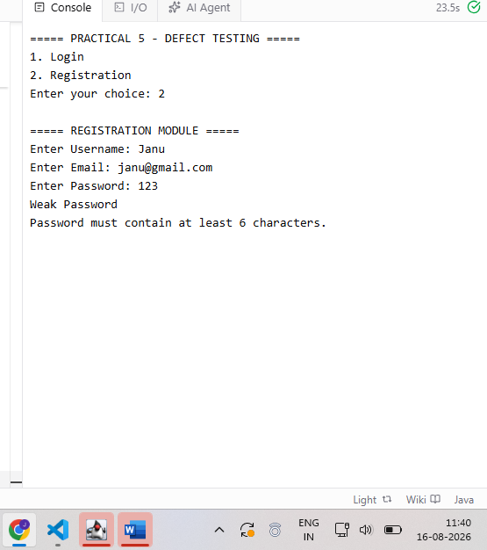

Scenario ID: 5g

Test Steps:

1.Open the registration page.
2.Enter valid registration details.
3.Enter a strong password.
4.Submit registration.

Test Input:

Valid username
Valid email
Strong password

Expected Result:

Registration should be completed successfully.

Actual Result:

Registration is accepted successfully.

Status:

PASS

Comments:

Normal registration functionality works successfully.

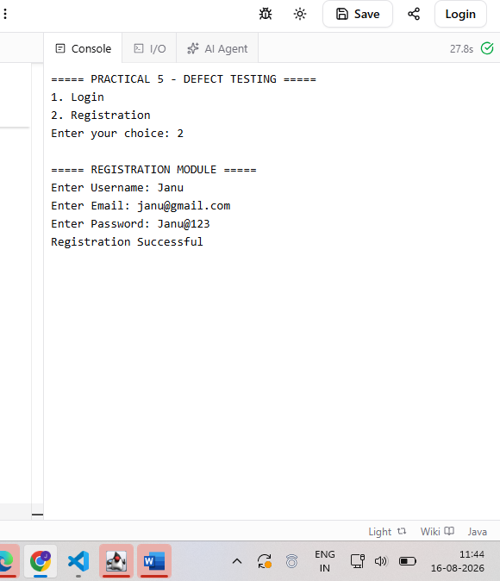

Scenario ID: 5h

Test Steps:

1.Open registration page.
2.Enter username and email.
3.Enter a weak password.
4.Submit the form.

Test Input:

Password: Weak password

Expected Result:

System should display a validation message and prevent registration.

Actual Result:

Weak password is accepted.

Status:

FAIL

Comments:

BUG-002 reproduced successfully. Severity: Low, Priority: Medium.

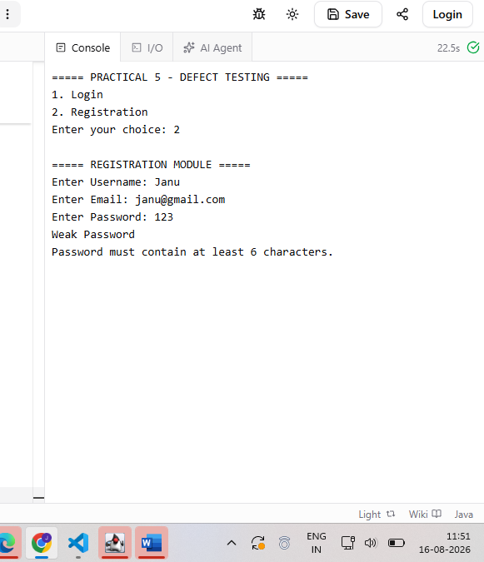

Scenario ID: 5i

Test Steps:

1.Open registration page.
2.Enter registration information.
3.Use another weak password.
4.Submit.

Test Input:

Password: 123

Expected Result:

System should reject the weak password.

Actual Result:

System accepts the weak password.

Status:

FAIL

Comments:

Same registration password-validation defect reproduced with another input. Severity: Low, Priority: Medium.

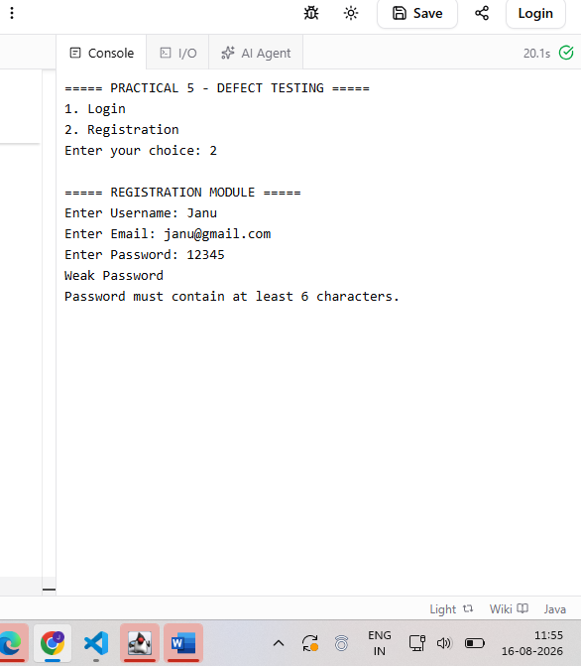

Scenario ID: 5j

Test Steps:

1.Open registration page.
2.Enter username.
3.Enter email.
4.Enter weak password.
5.Observe validation before submission.

Test Input:

Username: user2
Email: user2@test.com
Password: 12345

Expected Result:

Password validation message should be displayed before registration.

Actual Result:

No proper password-strength validation is displayed.

Status:

FAIL

Comments:

BUG-002 confirmed. Weak password validation is missing. Severity: Low, Priority: Medium.

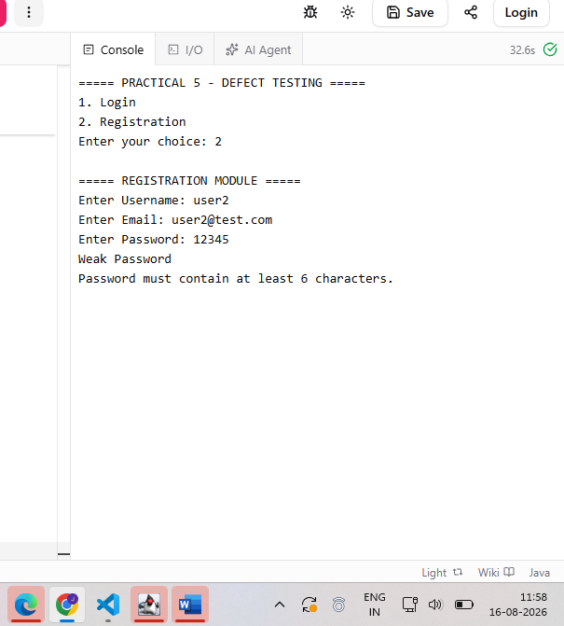

Scenario ID: 5k

Test Steps:
1.Open the payment page.
2.Enter valid payment details.
3.Observe page loading time.

Test Input:

Valid payment details

Expected Result:

Payment page should load within an acceptable response time.

Actual Result:

Payment page takes noticeably longer to load.

Status:

FAIL

Comments:

BUG-003 identified – Payment page loading/performance issue. Severity: High, Priority: High.
loading.
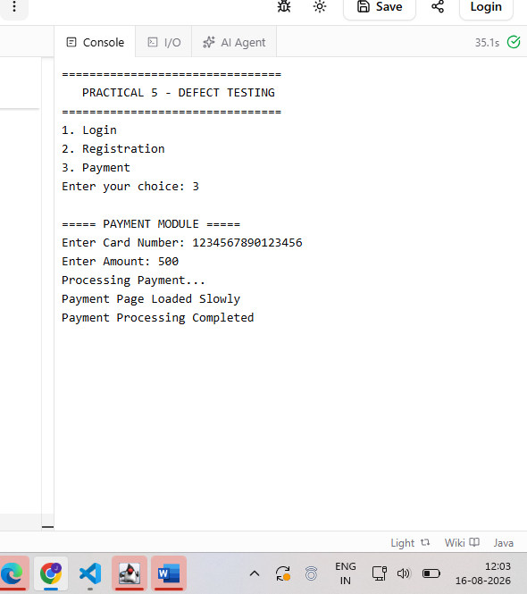

Scenario ID: 5l

Test Steps:

1.Open payment page.
2.Enter valid payment information.
3.Proceed to payment processing.
4.Observe response.

Test Input:

Valid payment details

Expected Result:

Payment processing page should respond normally without unnecessary delay.

Actual Result:

Payment page responds slowly.

Status:

FAIL

Comments:

BUG-003 reproduced successfully. Severity: High, Priority: High.
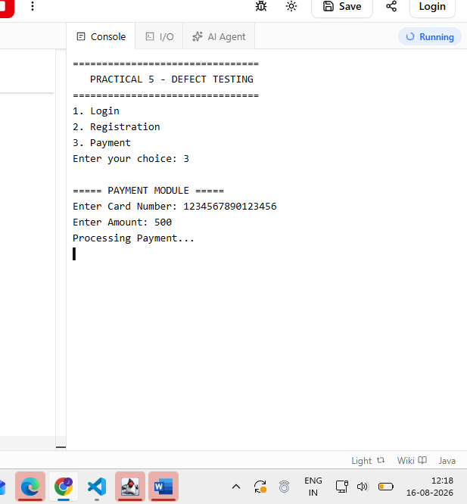

Scenario ID: 5m

Test Steps:

1.Open payment page.
2.Navigate to payment processing.
3.Observe loading behavior.
Test Input:

Valid payment details

Expected Result:

Payment processing screen should load properly and promptly.

Actual Result:

Payment screen takes longer to load.

Status:

FAIL

Comments:

Same payment performance defect reproduced. Severity: High,

Priority: High.

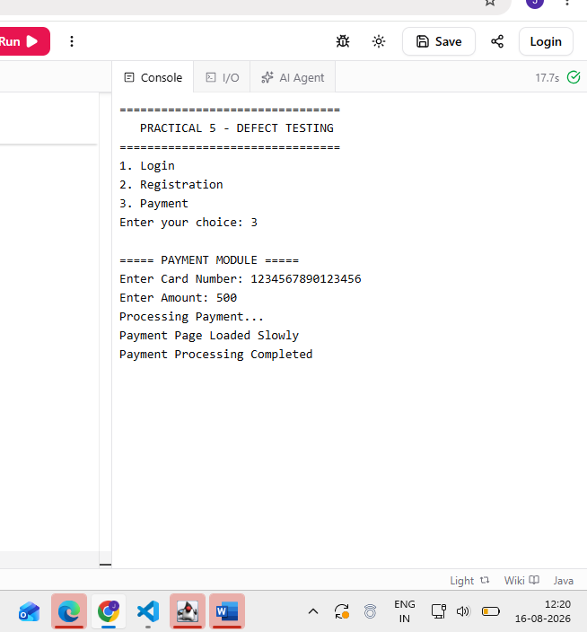

Scenario ID: 5n

Test Steps:

1.Execute login test with empty password.
2.Execute registration test with weak password.
3.Execute payment page test.

Test Input:

1.Blank password
2.Weak password
3.Valid payment details

Expected Result:

Login should validate blank password, registration should reject weak password, and payment page should load normally.

Actual Result:

Login validation is missing, weak password is accepted, and payment page loads slowly.

Status:

FAIL

Comments:

Three documented defects were reproduced successfully.

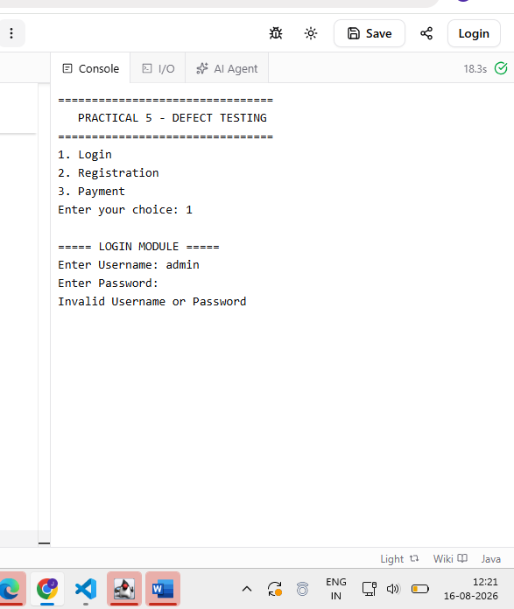

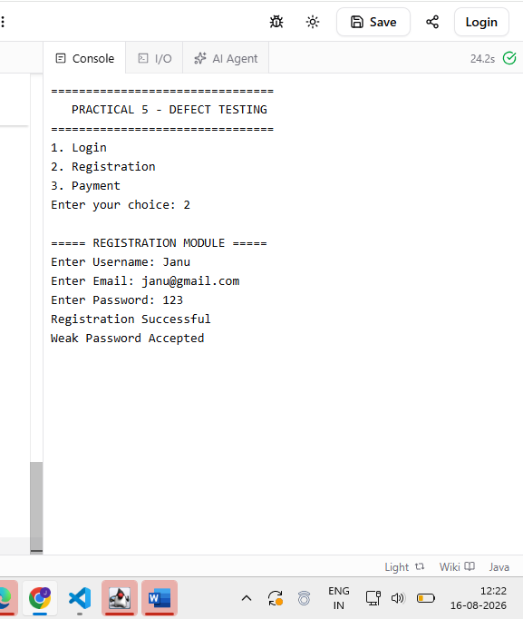

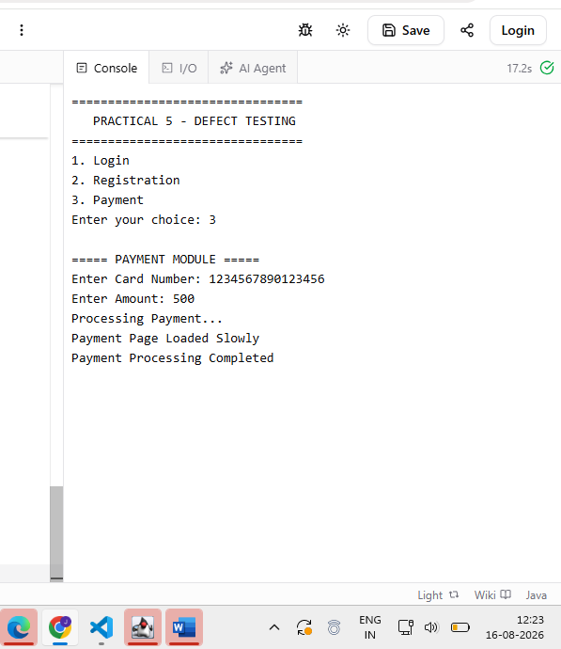

Scenario ID: 5o

Test Steps:

1.Review all observed defects.
2.Record defect description.
3.Assign severity and priority.
5.Prepare reproduction evidence.

Test Input:

BUG-001
BUG-002
BUG-003

Expected Result:

Each defect should have clear reproduction steps, severity, priority, and screenshot evidence.

Actual Result:

All three documented defects have been identified and classified.

Status:

FAIL

Comments:

Professional defect-reporting verification completed.
BUG-001: Severity – Medium, Priority – High
BUG-002: Severity – Low, Priority – Medium
BUG-003: Severity – High, Priority – High

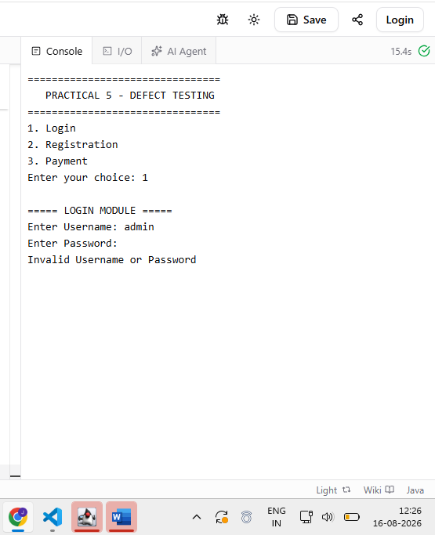

BUG-001 – Empty Password Validation Missing

Expected:

Password required validation message should be displayed.

Actual:
Generic “Invalid Username or Password” message is displayed.

Severity:

Medium

Priority:

High

Status:

Open

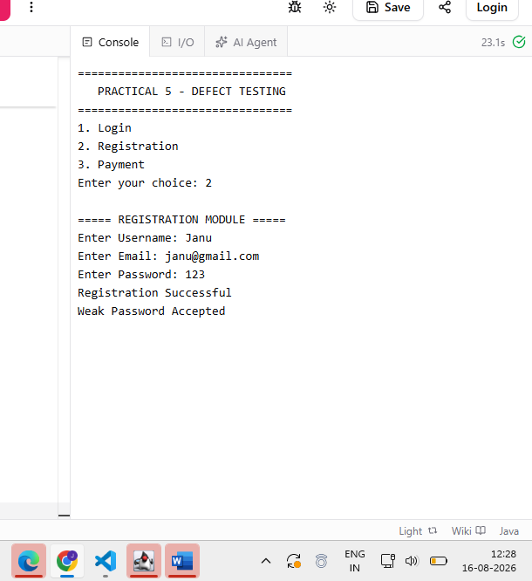

BUG-002 – Weak Password Accepted

Expected: Weak password should be rejected.

Actual: Weak password is accepted.

Severity: Low

Priority: Medium

Status: Open
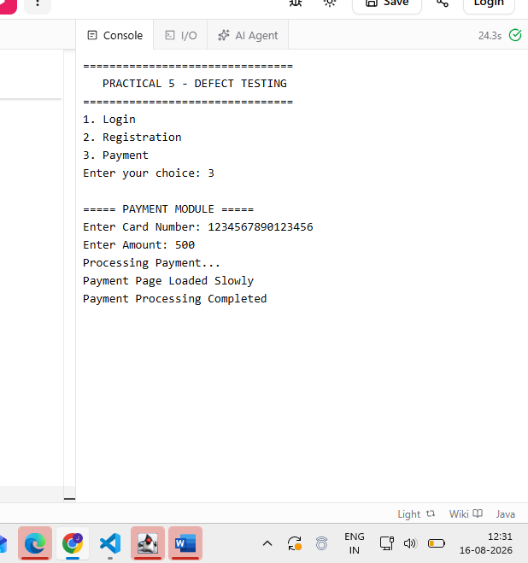

BUG-003 – Payment Page Responds Slowly

Expected: Payment page should respond/load normally without unnecessary delay.

Actual: Payment page responds slowly.
Severity: High

Priority: High

Status: In Progress

BUG IDENTIFICATION DETAILS

BUG-001
Bug ID: BUG-001
Defect Title: Empty Password Validation Missing

Module Name: Login Module

Feature Affected: User Authentication

Defect Description:

When the password field is left empty and the Login button is clicked, the system does not display the expected password validation message.

Defect Type: Functional

Severity: Medium

Priority: High

Environment: Windows 11, Google Chrome

Reported By: Janvi Patel

Steps to Reproduce:

1.Open the login page.
2.Enter username admin.
3.Leave password field blank.
4.Click Login.

Expected Result:

Password-required validation message should be displayed.

Actual Result:

No validation message is displayed.

Bug Status: Open

Resolution: Pending

Retest Status: Not Retested

Remarks: Needs client-side validation.

BUG-002

Bug ID: BUG-002

Defect Title: Weak Password Accepted

Module Name: Registration Module

Feature Affected: Password Validation

Defect Description:

The registration module accepts a weak password without displaying proper password-strength validation.

Defect Type: Functional

Severity: Low

Priority: Medium

Environment: Windows 11, Google Chrome

Reported By: Janvi Patel

Steps to Reproduce:

1.Open the registration page.
2.Enter username and email.
3.Enter a weak password.
4.Submit the registration form.

Expected Result:

System should reject weak password and display password-strength validation.

Actual Result:

Weak password is accepted.

Bug Status: Open

Resolution: Pending

Retest Status: Not Retested

Remarks: Improve password validation.

BUG-003

Bug ID: BUG-003

Defect Title: Payment Page Loads Slowly

Module Name: Payment Module

Feature Affected: Payment Page Performance

Defect Description:

The payment page takes longer than expected to load during payment processing.

Defect Type: Performance

Severity: High

Priority: High

Environment: Windows 11, Google Chrome

Reported By: Janvi Patel

Steps to Reproduce:

1.Open the payment page.
2.Enter valid payment details.
3.Proceed to payment processing.
4.Observe the loading behavior.

Expected Result:

Payment page should load properly within an acceptable response time.

Actual Result:
Payment page takes noticeably longer to load.

Bug Status: In Progress

Resolution: Under Investigation

Retest Status: Not Retested

Remarks: Performance issue needs investigation.

Observation

1.Login validation is missing when the password field is left empty.

2.Registration accepts weak passwords without proper validation.

3.Payment page loads slowly, indicating a performance issue.
Defects were identified and reproduced using defined test scenarios.

4.Severity and priority were assigned according to the impact and urgency of the defects.

5.Screenshots should be attached as evidence for the reproduced defects.

Output

Defects identified and documented successfully with reproduction steps, severity, priority, status, and screenshot evidence.

Conclusion

The practical successfully demonstrates defect identification, reproduction, classification, and professional bug reporting for a web application.

